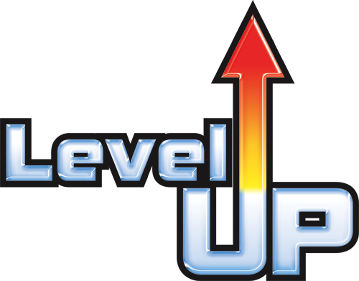
Leader Board Points
Level-Up Chart
10 Points – Upgrade your Avatar to
20 Points – 1 entry into prize drawing
25 Points – 1 lollipop or Jolly Rancher
30 Points – Upgrade your Avatar – pick your own!
40 Points – 2 entries into prize drawing
50 Points – 1 free soft drink
60 Points – Lunch with the Chief – Bring two friends
70 Points – Sit at Mr. Marc’s desk during class
80 Points – 2 entries into prize drawing
90 Points – +5 Points on any test
100 Points – Free snacks for your class
AUTOMATIC POINTS
- Every 5 Badges on Edmodo (show Mr. Marc) = 3 Points
- Every 50 points the whole class earns = Class Reward
- Every 100% on test = 2 Points

PRIZE DRAWING
- One $5.00 gift card to Yogli Mogli, Chick Fil A, or Brusters
- One king-size candy bar of winner’s choice

