Schools experiment with magnetic pouches that lock students' cellphones
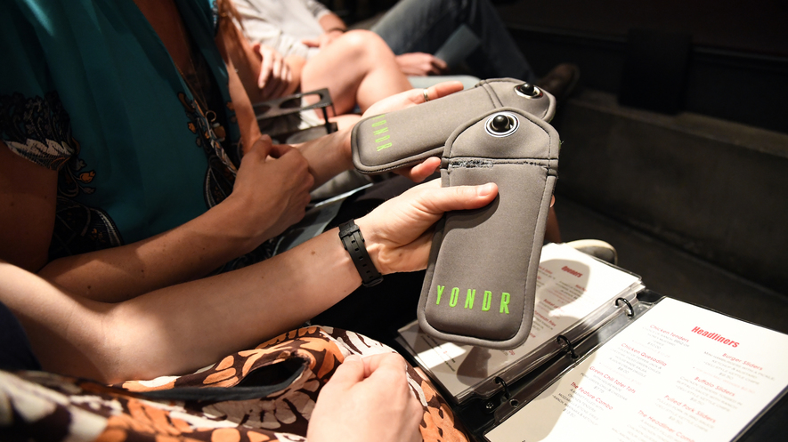
Services like Yondr allow patrons to bag and store their cellphones during live performances and also for students to keep their phones but not use them at school. Photo by: John Leyba/The Denver Post via Getty Images
By The Guardian, adapted by Newsela staff
Published:09/10/2019
Word Count:710
Recommended for:Middle School - High School
Text Level:6

In the age of smartphones, teachers and educators find themselves saying the same things. They are constantly telling students to put their phones away or to stop texting.
Most teenagers today have never known a world without smartphones.
The Pew Research Center said 95 percent of all teens currently have access to or own a smartphone. Also 45 percent are almost always online. That means teachers have to teach students who are distracted.
Most schools ban or regulate phone usage during school hours. Teachers often have to take away phones or write up students for using them. Now they are looking at more drastic measures.
This school year, more than 1,000 schools nationwide will be using Yondr. It is a pouch system that allows students to lock away their phones while in class.

No Phone Access Until The End Of The Day
Each morning when students arrive at school, they magnetically lock their devices into their own personal green-and-gray pouches. Then they can keep the pouches with them, but they cannot unlock them until the end of the school day. Students can tap them on unlocking magnet stations throughout the school.
This idea is not new. Musicians have been using Yondr to stop people from filming their concerts since 2014.
More schools have started using the pouches in recent years.
Yondr spokesperson Kelly Taylor said the number of people using the pouches has tripled this year.
Allison Silvestri is the former principal of San Lorenzo High School east of San Francisco in California. The school launched Yondr three years ago and saw good results. Students were paying more attention in class.

Increased Interaction, Decreased Referrals
She said it was good to see students interacting with each other and teachers. The school also saw a decrease in referrals for defiance and disrespect.
Edward Huang, age 16, is a student who was part of a pilot program testing Yondr at his high school in California. He has noticed a difference in his peers since then.
"People aren't distracted," Huang said. "Even people who were on their phones in minor ways, like checking the time and checking notifications, those minor ways add up and have an effect on how engaged you are. Socially, it has improved us. Even if it's all of us talking about how much we hate it, having something to hate is a conversation topic."
However, there have also been some problems. For example, employers trying to get in touch with students during the school day could not contact them.
Additionally, students figured out ways to hack the pouch. Someone created a video showing how to break into the Yondr on Instagram.

"Pretty Cool" Training Wheels
Audrey Morganstern, a 16-year-old junior at San Mateo High School, is a fan of Yondr. She said it is like training wheels for people who want to not use their phones as much. She added that she has had "pretty cool" conversations with people because she could not use her phone to avoid awkward situations.
Leadership High School in San Francisco, California, started using Yondr this year. However, Principal Beth Silbergeld said the school allows students the opportunity to unlock their pouches during lunch.
She liked the idea of Yondr because the phones remain the students' responsibility. Silbergeld said when schools check phones into a box, it becomes a huge responsibility for teachers.
Yondr comes after years of teachers and educators noticing that asking students to put their phones away was not working.
The freshman class at Berkeley High School in California is trying a Yondr pilot program this year, while the rest of the school operates as usual.
"Adults struggle with the addictive nature of this technology, so you have to have compassion for children who have grown up with this technology," said Angela Coppola, who teaches 10th- and 11th-grade history.
Coppola added that the constant communication has taken a toll on her students. For example, she said teachers have noticed an increase in student anxiety in the past five years.
She would support an effort to get students to go device-free for the day.
"The technology is so persuasive," Coppola said. "How can we expect people who are still developing to have stronger willpower than actual adults? We can't."

