What Is the International Space Station?
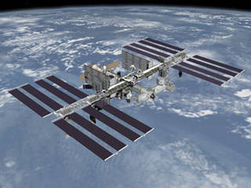
The space station is one of the brightest objects in the sky.
Credits: NASA
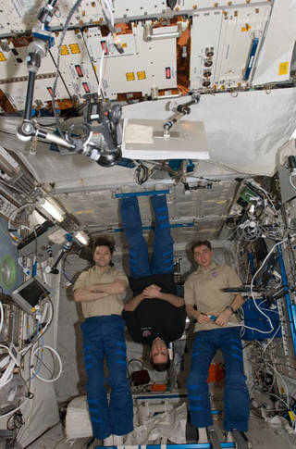
Pictured here are members of the 17th crew to live aboard the space station.
Credits: NASA
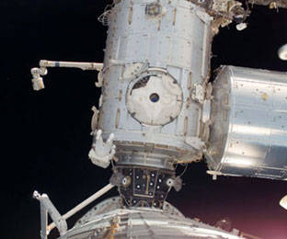
Astronauts work in spacesuits to help build the space station.
Credits: NASA
This article is part of the NASA Knows! (Grades K-4) series.
The International Space Station is a large spacecraft. It orbits around Earth. It is a home where astronauts live.
The space station is also a science lab. Many countries worked together to build it. They also work together to use it.
The space station is made of many pieces. The pieces were put together in space by astronauts. The space station's orbit is approximately 250 miles above Earth. NASA uses the station to learn about living and working in space. These lessons will help NASA explore space.
How Old Is the Space Station?
The first piece of the International Space Station was launched in 1998. A Russian rocket launched that piece. After that, more pieces were added. Two years later, the station was ready for people. The first crew arrived on November 2, 2000. People have lived on the space station ever since. Over time more pieces have been added. NASA and its partners around the world finished the space station in 2011.
How Big Is the Space Station?
The space station is as big inside as a house with five bedrooms. It has two bathrooms, a gymnasium and a big bay window. Six people are able to live there. It weighs almost a million pounds. It is big enough to cover a football field including the end zones. It has science labs from the United States, Russia, Japan and Europe.
What Are the Parts of the Space Station?
The space station has many parts. The parts are called modules. The first modules had parts needed to make the space station work. Astronauts also lived in those modules. Modules called "nodes" connect parts of the station to each other. Labs on the space station let astronauts do research.
On the sides of the space station are solar arrays. These arrays collect energy from the sun. They turn sunlight into electricity. Robot arms are attached outside. The robot arms helped to build the space station. They also can move astronauts around outside and control science experiments.
Airlocks on the space station are like doors. Astronauts use them to go outside on spacewalks.
Docking ports are like doors, too. The ports allow visiting spacecraft to connect to the space station. New crews and visitors enter the station through the docking ports. Astronauts fly to the space station on the Russian Soyuz. The crew members use the ports to move supplies onto the station.
Why Is the Space Station Important?
The space station is a home in orbit. People have lived in space every day since the year 2000. The space station's labs are where crew members do research. This research could not be done on Earth.
Scientists study what happens to people when they live in space. NASA has learned how to keep a spacecraft working for a long time. These lessons will be important in the future.
NASA has a plan to send humans deeper into space than ever before. The space station is one of the first steps. NASA will use lessons from the space station to get astronauts ready for the journey ahead.

